- Law of addition – general and special
- Law of multiplication – general and special
- Conditional probability
- Baye’s theorem

Mutually exclusive – events cannot occur together.
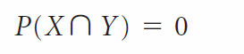
Being an Indian and American citizen are mutually exclusive.

Independent events – probability of one event does not depend on the other event
Market going up or down and whether it rains or not are independent events

General law of addition
In a batch of 120 students, 70 students say they have a car at home, 60 say they have a house of their own. What is number of students having both house AND a car. Assume everybody in the class has either a car or a home.
P(Car) = 70
P(House) = 60
P(Car and House) = x
P(Car or House) = 120
120 = 70 + 60 – x
x = 130 – 120 = 10
When the different mutually exclusive events are connected with OR, then we add up the probabilities to get the probability of either of the events occurring
P(X | Y) Probability of the event X occurring given the fact that Y has already occurred
X – Sudeep is late for the class
Y – Rains in Bangalore

General law of multiplication
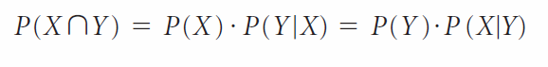
Special law of multiplication
